**Terraform State Management and Remote Configuration**

**TerraWeek Day 4**

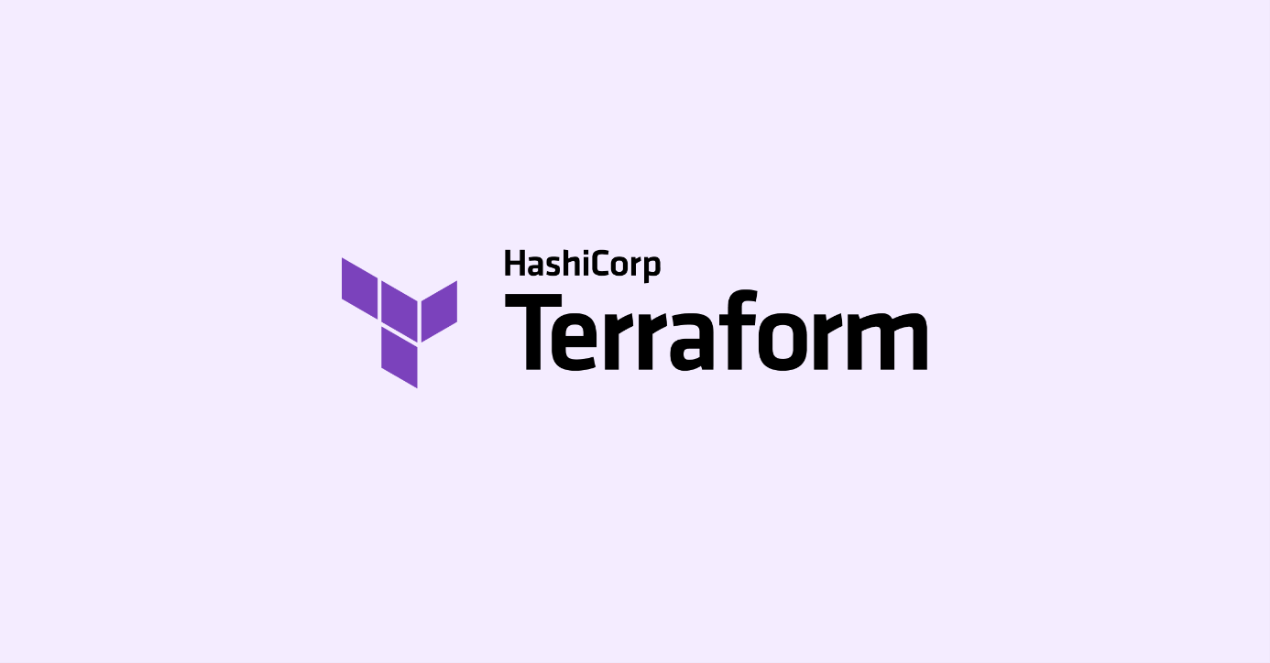

**Task 1: Importance of Terraform State**

**📚 Research: Dive into the importance of Terraform state in managing infrastructure. Discover how Terraform state helps track the current state of resources and ensures smooth infrastructure provisioning and management.**

Terraform state is a vital component of infrastructure management with Terraform. It helps keep track of resource states, ensures smooth provisioning, and simplifies infrastructure management. In this blog post, we'll explore the importance of Terraform state in a concise and easy-to-understand manner.

1. Tracking Resource State: Terraform state acts as a record of your infrastructure's current state. It keeps track of resources and their attributes, enabling Terraform to understand what needs to be changed to achieve the desired state.
2. Ensuring Dependency Management: Terraform state helps manage dependencies between resources. By understanding resource relationships, terraform can provision, update, or destroy resources in the correct order, reducing conflicts and ensuring smooth infrastructure deployment.
3. Achieving Idempotent Operations: Terraform follows the principle of idempotency, meaning that applying the same configuration multiple times yields the same result. Terraform state plays a key role in this by helping Terraform determine the necessary changes required to align the infrastructure with the desired state consistently.
4. Enabling Collaboration: Terraform state supports collaboration among team members. It implements a locking mechanism to prevent simultaneous modifications by multiple users. This promotes coordination, data integrity, and efficient teamwork on infrastructure management tasks.
5. Powering Planning and Execution: During planning, Terraform compares the desired state in the configuration with the current state stored in the state file. It generates an execution plan based on the differences, ensuring accurate and reliable infrastructure changes during the apply phase.
6. Ensuring State Persistence: To ensure reliability and accessibility, it's crucial to persist Terraform state in a remote backend. This provides durability, versioning, and accessibility from multiple locations, enabling easy rollbacks and facilitating auditing of changes.

**Task 2: Local State and terraform state Command**

📚 **Understand**: Explore different methods of storing the state file, such as local or remote storage. Create a simple Terraform configuration file and initialize it to generate a local state file. Get hands-on with the terraform state command and learn how to use it effectively to manage and manipulate resources.

1. **Storing the State File:** Terraform state file is essential for tracking the current state of resources. There are two common methods for storing the state file: local and remote storage.

* **Local State:** By default, terraform stores the state file locally in the project directory. This method is suitable for small projects or personal use. It's easy to set up by running **terraform init** in the project directory, which generates the local state file. However, local state is not suitable for collaboration or when working with a team.
* **Remote State:** For larger projects or team collaboration, it's recommended to use remote state storage. Remote state enables multiple users to work on the same infrastructure and provides features like concurrency control and versioning. Remote state can be stored in cloud storage services like Amazon S3, Azure Blob Storage, or by using HashiCorp Terraform Cloud. To use remote state, you need to set up a backend configuration that specifies the storage location and credentials.

1. Using the **terraform state** Command: The **terraform state** command is a powerful tool for managing and manipulating resources within the Terraform state file. Here are some useful commands:

* **terraform state list**: Lists all resources stored in the state file.
* **terraform state show <resource_address>**: Shows detailed information about a specific resource.
* **terraform state mv <resource_address> <new_resource_address>**: Moves a resource to a new address within the state file.
* **terraform state rm <resource_address>**: Removes a resource from the state file.

These commands allow you to inspect, modify, or delete resources directly in the Terraform state file. They provide fine-grained control over your infrastructure and help ensure smooth provisioning and management.

**Task 3: Remote State Management**

📚 **Explore**: Delve into remote state management options like Terraform Cloud, AWS S3, Azure Storage Account, or HashiCorp Consul. Select one remote state management option and thoroughly research its setup and configuration process. Become familiar with the steps required to leverage remote state management in your Terraform workflow.

Remote state management options such as Terraform Cloud, AWS S3, Azure Storage Account, and HashiCorp Consul provide secure and scalable storage for Terraform state files.

* Terraform Cloud: Managed service by HashiCorp for collaborative state management and team collaboration.
* AWS S3: Scalable object storage service by Amazon Web Services, suitable for storing and versioning Terraform state files.
* Azure Storage Account: Scalable storage solution in Microsoft Azure ecosystem, offering reliable storage for Terraform state files.
* HashiCorp Consul: Distributed service mesh and key-value store, providing highly available storage with access control for Terraform state.

**Setup and Configuration Process for AWS S3 as a Remote Backend**

1. Create an S3 Bucket:
   * Log in to the AWS Management Console.
   * Navigate to the S3 service.
   * Click on "Create bucket" and provide a unique bucket name and region.
   * Configure any additional settings as per your requirements and create the bucket.
2. Configure AWS CLI:
   * Install and configure the AWS CLI on your local machine.
   * Run the **aws configure** command and provide your AWS access key ID, secret access key, default region, and output format.
3. Update Terraform Configuration:
   * Open your Terraform configuration file (e.g., **main.tf**).
   * Add the following block to configure the remote state backend:
4. Initialize Terraform:
   * Run **terraform init** in the command line.
   * Terraform will detect the changes and prompt you to copy the existing local state to the remote state. Confirm by typing **yes**.
5. Apply Changes:
   * After the initialization, you can use Terraform as usual.
   * Run **terraform apply** to create or update resources.
   * Terraform will store the state file in the configured S3 bucket.

terraform {

backend "s3" {

bucket = " bucket_name "

key = "terraform.tfstate"

region = " us-east-1"

}

}

**Task 4: Remote State Configuration**

📚 **Modify**: Enhance your Terraform configuration file to store the state remotely using the chosen remote state management option. Include the necessary backend configuration block in your Terraform configuration file to enable seamless remote state storage and access.

Step 1 : Firstly, create an S3 bucket to store state files remotely.

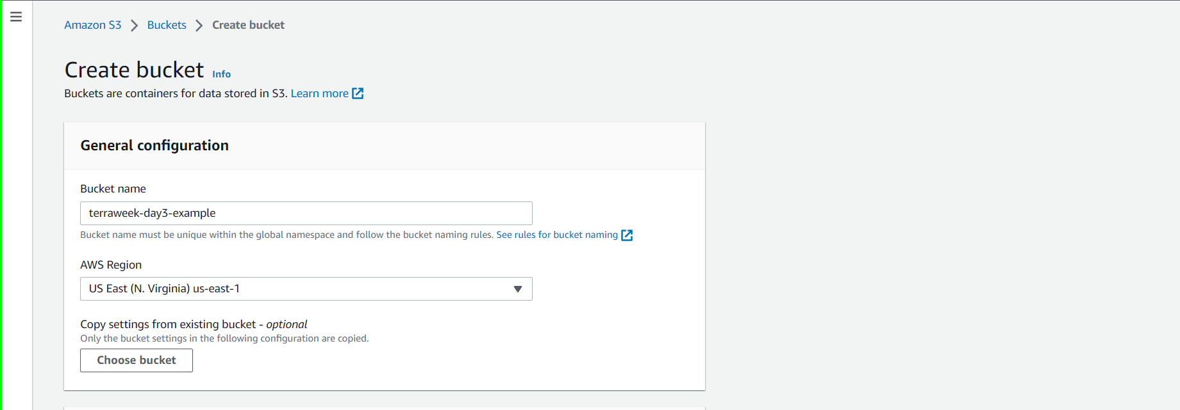

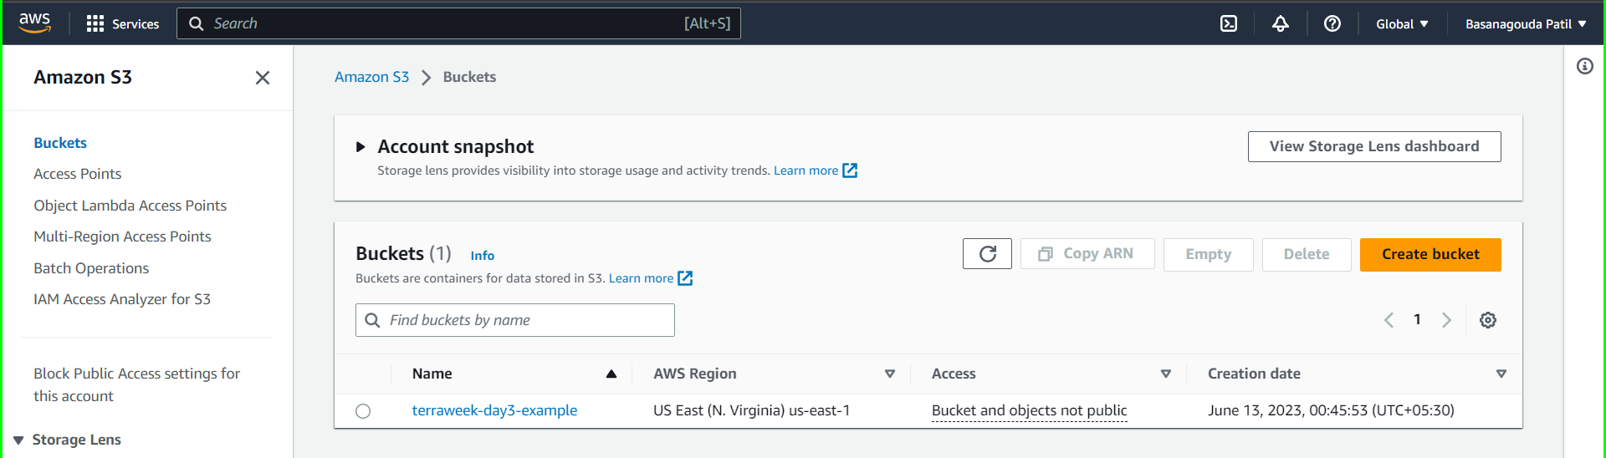

Step 2: To store the state remotely let's modify the Terraform configuration file [main.tf](http://main.tf/) to use AWS S3 as the remote backend.

terraform {

required_providers {

aws = {

source = "hashicorp/aws"

version = "5.2.0"

}

}

backend "s3" {

bucket = "terraweek-day3-example"

key = "terraform.tfstate"

region = "us-east-1"

}

}

provider "aws" {

region="us-east-1"

}

resource "aws_instance" "myec2" {

ami = "ami-04a0ae173da5807d3"

instance_type = "t2.micro"

vpc_security_group_ids = [aws_security_group.ownsg.id]

tags = {

Name = "terraform-example"

}

lifecycle {

create_before_destroy = true

prevent_destroy = false

}

}

resource "aws_security_group" "ownsg" {

name = "own-sg"

ingress {

from_port = 80

to_port = 80

protocol = "tcp"

cidr_blocks = ["0.0.0.0/0"]

}

egress {

from_port = 0

to_port = 0

protocol = "-1"

cidr_blocks = ["0.0.0.0/0"]

}

}

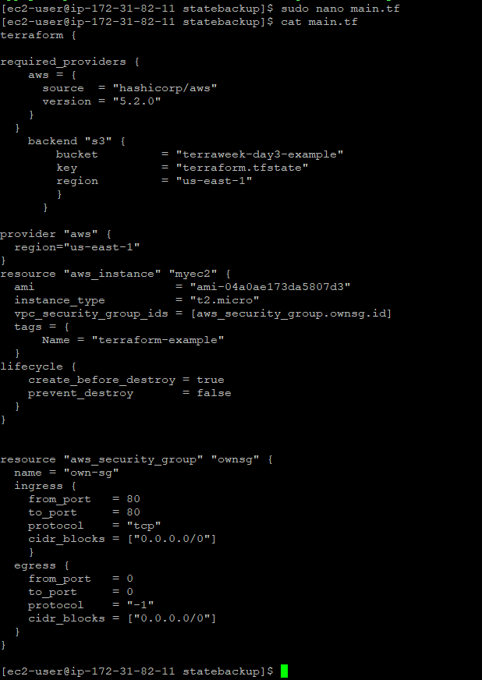

Step 3: Run the terraform init command to initialize Terraform and configure the backend to use AWS S3

remote backend.

Step 4: Run Terraform commands such as terraform plan and terraform apply, the state will be stored in AWS S3, enabling remote state management and collaboration.

Step 5: Then finally, check the bucket, state file is there.

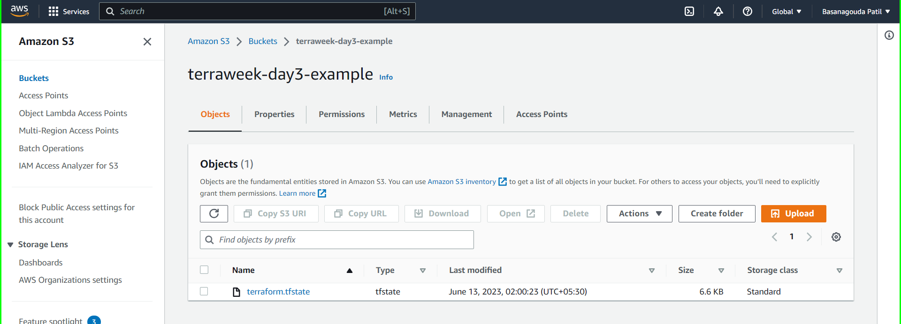

**Conclusion**:

From this blog, we learned about, Terraform state is a crucial aspect of infrastructure management. It tracks resource states, manages dependencies, ensures idempotent operations, enables collaboration, and powers planning and execution. By leveraging remote state management options like Terraform Cloud, AWS S3, we can achieve scalable and secure storage for Terraform state files.

Furthermore, we explored storing state files locally or remotely and learned about the powerful terraform state command for managing resources within the state file. Using remote state management enhances collaboration and facilitates efficient infrastructure provisioning and management.

Finally, we discussed the setup and configuration process for AWS S3 as a remote backend, enabling seamless remote state storage and access.

By incorporating these practices into our Terraform workflows, we can streamline infrastructure management and ensure reliable and consistent provisioning. Happy learning and exploring the world of Terraform!

🚀 Excited to share my insights on TerraWeek Day 4!

Today, let's dive into the importance of Terraform state and explore different deployment methods. Don't forget to use the hashtags #TerraformState #InfrastructureManagement #RemoteStateManagement to join the conversation!

Task 1: Importance of Terraform State 🔍 Research: Discover how Terraform state helps track resource states and ensures smooth infrastructure management. #TerraformState #InfrastructureManagement

Task 2: Local State and terraform state Command 🔍 Understand: Learn about storing state files locally or remotely and explore the powerful terraform state command for managing resources. #LocalState #RemoteState #TerraformStateManagement

Task 3: Remote State Management 🔍 Explore: Delve into remote state management options like Terraform Cloud, AWS S3, Azure Storage Account, or HashiCorp Consul. #RemoteStateManagement #TerraformCloud #AWS #Azure #HashiCorpConsul

Task 4: Remote State Configuration 🔍 Modify: Enhance your Terraform configuration file to store state remotely using your chosen option. #RemoteStateConfiguration #InfrastructureManagement

Let's keep exploring the world of Terraform together! Happy #TerraWeek! 💪✨

#Terraform #CloudComputing #DevOps